Shubham Shekhaliya

U18CO018

Assignment-3(Tutorial)(MIT)

1-> WALP to check the forth bit of a byte stored at location 3000H is 0 or 1. If 0 store 00h else store FFH at location 3002H.

Code:-

mvi a,3Ah

sta 3000h

lxi h,3000h ; load data into memory from address 3000H

mov a ,m ; move in to the accumulator

lxi h,3002h ;where we want store the ans

ani 08h ; and with 2^3 as we want to check fourth bit

jnz noz ; if zero flag value is 0 which means 1

; else set 00

mvi m,00H

jmp end

noz: mvi m,8fH

end: hlt

Output:-

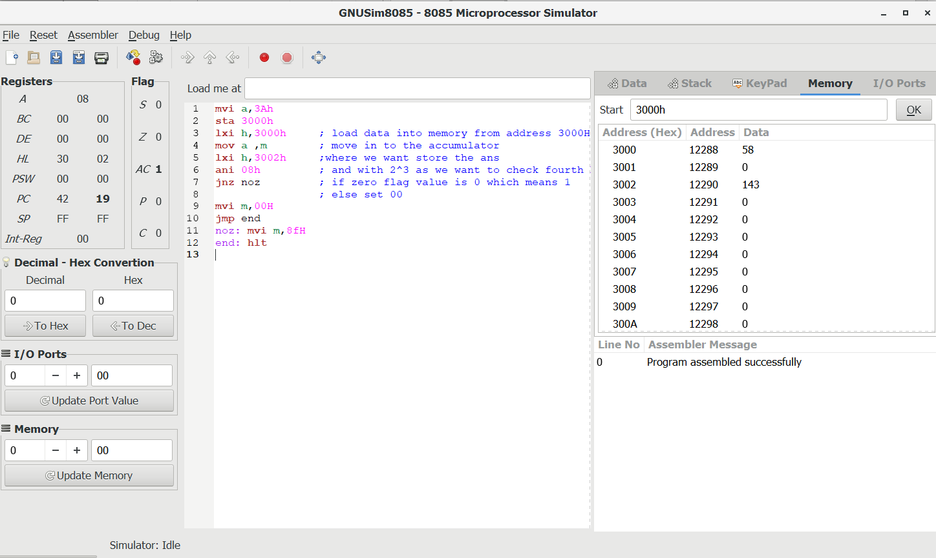

2-> Write Assembly language program to count the number of 1s in 8-bit number stored in register B.

Code:-

;let's store data in register B

mvi b, 4Ch ;data on we want ro check

mvi c,00H ;contains ans how many one's till

mvi d,08H ;store how many bits we want to check

mov a,b ;transfer in to accumulator

loop: rar ;rotate right with carry

jnc next ; if carry 0 then jump

inr c ; if carry 1 then increment ans

next: dcr d ; decrement ans by 1

jnz loop ; do loop till counter is zero

mov a,c ; store ans in to the accumulator

hlt

Output:-

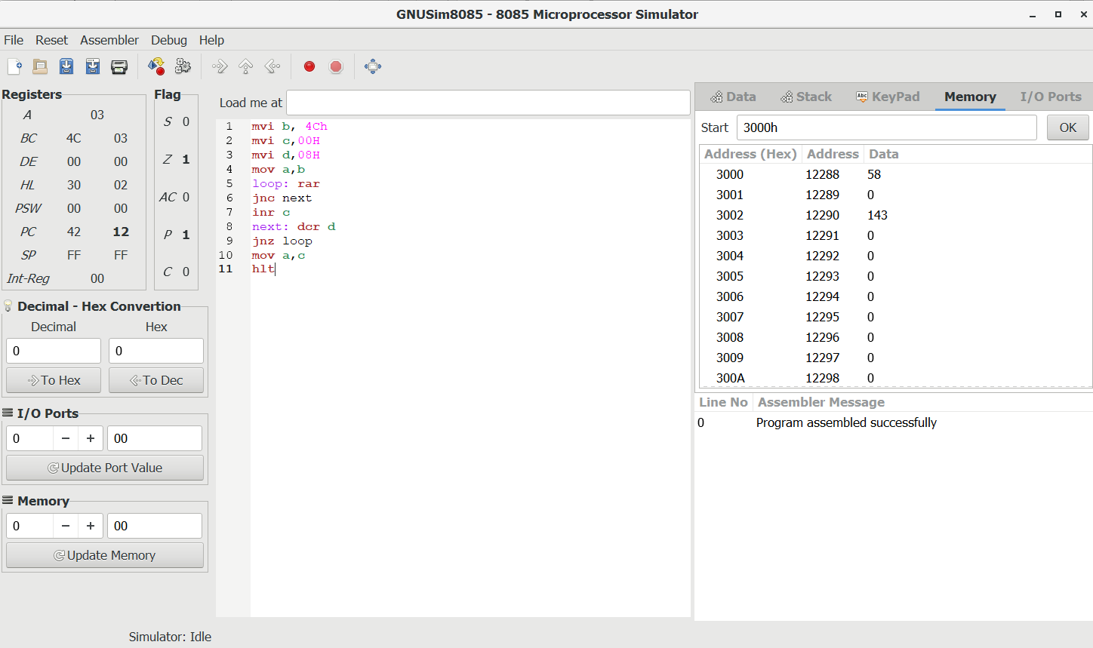

3-> There is an array of some elements. Write Assembly language program to count number of elements that are lesser than 09H.

Code:-

lxi h,07D0H

mvi c ,00H

mov d, m ;d register contains counter

next: inx h

mov a,m

cpi 09H ;compare with 09

jnc skip ;if greater

inr c ;if smaller then increment ans

skip: dcr d

jnz next

mov a,c ;store result into the accumulator

hlt

Output:-

